UK Safety Alert

Truckmixer Driver hit by Swinging Chute

Details of the Incident

A tipper truck fitted with a hiab arm and grab needed to be loaded from a mixer truck at a concrete plant. To do this the mixer driver reversed his mixer truck. Loaded with the concrete, up onto the collect loading ramp whilst the tipper was parked in front of and at 90 degrees to the ramp. Because of the size of the truck the mixer driver had to raise his chute to the maximum angle to clear the truck tail board corner post before lowering it down to allow the concrete to flow. After discharging the concrete the mixer driver returned to the rear of the mixer truck to raise the chute out of the tipper body.
At this point the tipper driver moved his vehicle forward, without being instructed to do so, and the rear corner post of the truck body struck the mixer discharge chutes with some force causing them to swing round towards the mixer driver. The chute struck the mixer truck ladder which took the majority of the impact before it struck the driver’s hand, which he had raised to protect his head. The driver received a gash to his right forefinger.

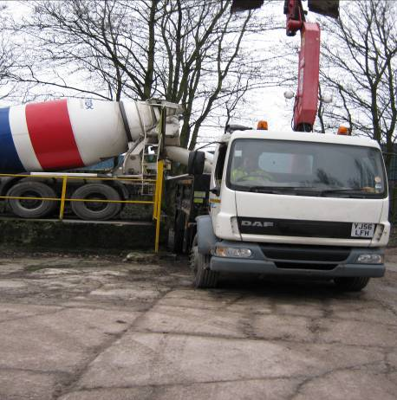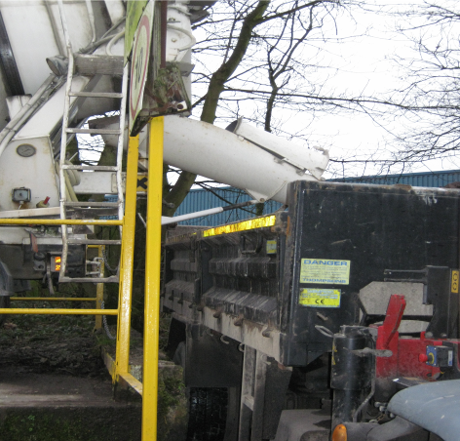

Learning Points

The truck mixer driver was extremely lucky not to be struck on the head by the discharge chutes or to be knocked off the ramp. It is always important when carrying out any task that involves more than one person or multiple vehicles that clear communications and actions are established before commencing the operation.
- The plan of how the material would be placed in the collect vehicle was not fully discussed with the collect driver.
- The problem caused by the high sides on the collect vehicle and how they would interfere with the swing of the mixer chute was not fully appreciated by the collect driver and this point was not brought to his attention.
- No member of staff was nominated to control the operation and consequently the collect driver made his own decision on when to move off.

